Step 1 – Log into your account

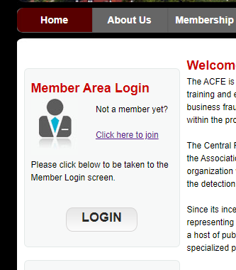

Step 2 – Select “View my Order History

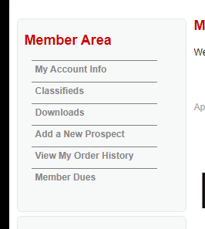

Step 3 – Select the “Open” status order for this event

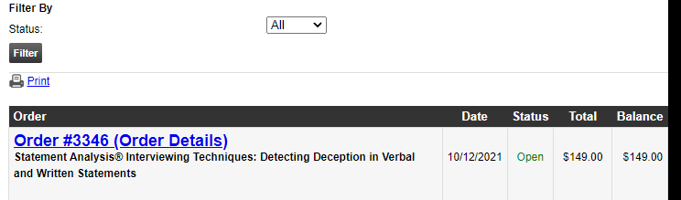

Step 4 – Click “Pay balance” and “Continue” to get to payment screen

