Click “Register Now”, then either enter your log-in information or continue as guest (Note: even if you are a member you may still register with the group pricing, for example if two employees are members and three are not)



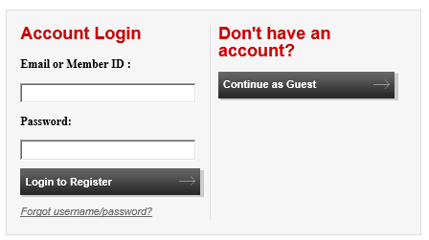

Input your information (or confirm your information is accurate if you’re logged in)
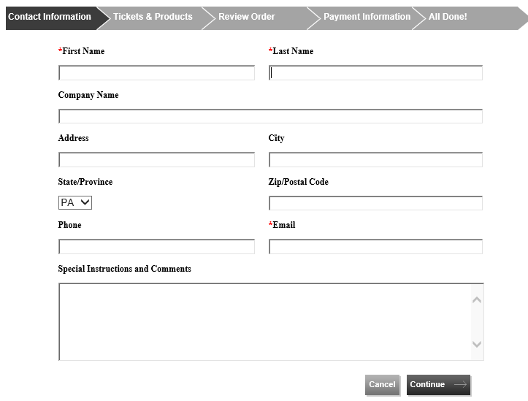

Select the appropriate number of tickets needed for your group and click “Add”

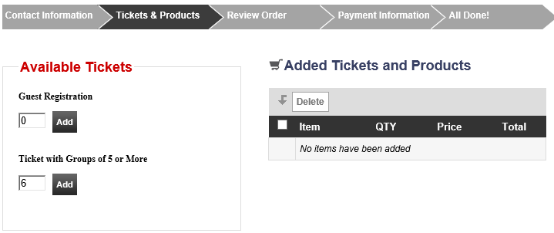

Populate information for each individual registering, including the group eligibility, such as employer, organization, or if spread across multiple employers, the individual organizing the group.

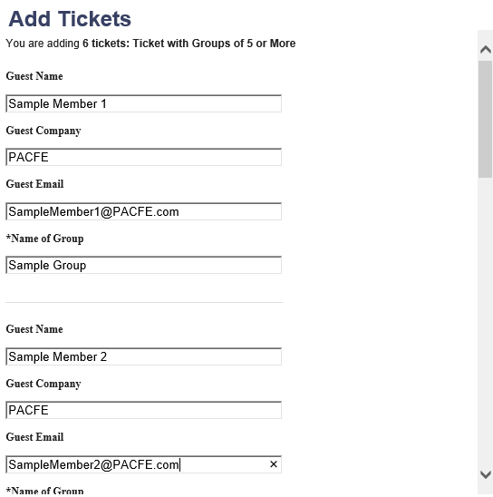

Once all of the names have been input, click “Add” and continue to payment.

